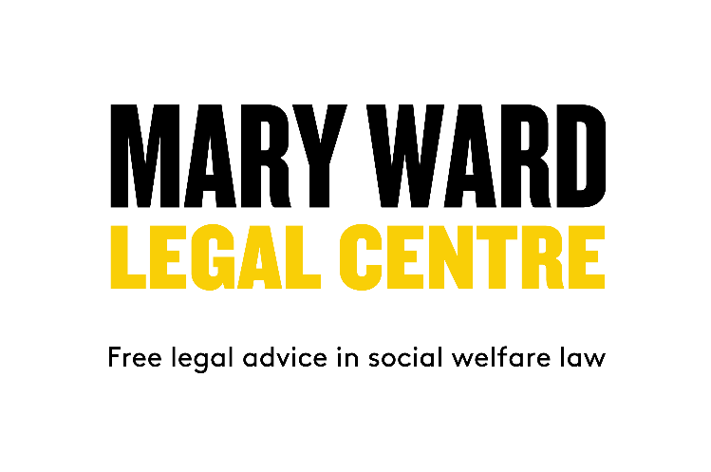

Generalist Adviser

Are you a generalist adviser looking for a new opportunity to tackle health inequalities?
Do you want to be part of an exciting new research project improving the lives of families in Tower Hamlets?

This a great opportunity to see the value of your advice work highlighted through expert research.

Mary Ward Legal Centre is looking to recruit two generalist advisers to be part of a new research project – Healthier Wealthier Families in East London – in partnership with UCL and University of York. We are looking for enthusiastic and committed advisers who believe in the importance of co-located services and evaluating the impact of advice on health.

You will provide generalist advice in Children’s Centres to families with newborns with the aim of maximising incomes and reducing poverty. The research will be evaluating the impact of the advice on health and wellbeing. You will be co-located in Children’s Centres and work closely with health visitors. You will be part of the research project and committed to data collection. You will have at least one year’s recent experience providing information and generalist level advice to members of the public on welfare benefits.

Mary Ward Legal Centre is a very friendly and supportive workplace with an excellent reputation for providing high quality legal advice. You will be supervised by experienced caseworkers and solicitors.
We offer excellent terms and conditions, flexible working, 35 days’ annual leave plus statutory bank holidays, and 6% employer's contribution to a pension scheme.
This post is 35 hours/week and is currently funded for 16 months.
Benefits
Salary: £ 29,407
Flexible working.
35 days’ annual leave in addition to statutory bank holidays.
6% employer's contribution to a pension scheme.
The post is 35 hours a week for a fixed term period of 16 months.
Closing date: 24 March 2025
Interviews: 31 March 2025

About Mary Ward Legal Centre
The Mary Ward Legal Centre is a pan-London charity providing free legal advice, casework and representation to people on a low income who otherwise could not afford to enforce their legal rights. Our vision is a society where everyone should have access to advice and representation to enable them to secure their legal rights and entitlements. Through the provision of free legal advice, we aim to tackle poverty and disadvantage through maximising incomes, reducing debts, saving homes and improving general wellbeing. The Legal Centre is part of the Mary Ward Settlement. The Settlement was established in the late 19th century to provide education and social services for the local community. Free legal advice has been given by the Settlement since this time.

We value working in partnership with other community organisations, and deliver advice through outreach. We have the Lexcel quality mark and have been commended for excellent client care. We have longstanding relationships with partners in the legal sector, including Linklaters, Clifford Chance, Eversheds, Weil Gotshal & Manges, Bishop & Sewell, and Farrer & Co.

We employ solicitors and caseworkers to provide specialist legal advice and representation in the following areas of law:

- Debt: rent or mortgage arrears; council tax arrears, utility debts; Magistrate Court debts; credit debts; bankruptcy proceedings; Debt Relief Orders; county court claims.
- Housing: homelessness; defending possession proceedings and warrants for eviction; serious disrepair where a tenant’s health is at risk due to poor housing conditions.
- Welfare Benefits: helping people gain their full benefit entitlement through challenging negative decisions.

In addition to our casework service, we run free weekly legal advice clinics, delivered by volunteer lawyers, in the areas of: employment, housing, family and general civil litigation.

Each year we give legal advice and support to over 3,000 new clients. This figure doesn’t include work supporting existing clients.

Over 40 per cent of the people we help report having a disability and/or long-term health condition. Over 60 per cent are from Black and minority ethnic backgrounds.

Clients access the services via face-to-face appointments at our offices and by telephone appointments.

The Mary Ward Legal Centre is a registered charity and company limited by guarantee. The only Company member is the Mary Ward Settlement whose Trustees govern the Legal Centre.

The organisation employs 23 paid staff. This includes solicitors, caseworkers, trainee solicitors, support staff and a director. There are two trainees seconded from Clifford Chance and one from Linklaters – these trainees are seconded for three and six months respectively.

Staff are divided into the following teams:
- Welfare Benefits & Housing
- Debt
- Access to Legal Services
- Senior Management Team

Funding and Income
The Centre has a turnover of approximately £1.1m. Funders include:
- Legal Aid Agency
- Money and Pensions Service – Debt Free Advice partnership
- London Borough of Camden
- Trust for London
- Henry Smith Charity
- Legal Education Foundation
- London Legal Support Trust
- Access to Justice Foundation

The Legal Centre receives some donations and support from law firms including Linklaters, Clifford Chance, Farrer & Co.Weil Gotshal and Manges, and Bishop & Sewell.

Diversity and equality
Mary Ward Legal Centre provides services to disadvantaged people of all backgrounds. Equality of opportunity is at the heart of the Centre’s practice and policy. We value diversity amongst our paid staff and volunteers.

We are committed to eliminating unlawful discrimination and promoting equality and diversity within our policies and procedures. This applies to our professional dealings with clients, all staff (including all volunteers), other legal service providers, experts and third parties.

Job Description

Job title: Generalist Adviser

Reporting to: Deputy Director

Purpose of the Post:

To provide generalist advice in Children’s Centres with the aim of maximising incomes and reducing poverty of the families recruited to the research project.

To ensure that services are delivered to the highest standard, are accessible and quality assured and where appropriate are delivered in accordance with funder requirements.

Duties and responsibilities:
- To provide generalist advice and support on welfare benefits to maximise the incomes of families in Children’s Centres.
- To work across several Children’s Centres in the borough of Tower Hamlets and build good working relationships with key staff in the Centres.
- To maintain an up-to-date knowledge of relevant areas of law and policy and undertake training as required.
- To ensure the advice and casework complies with funder requirements.
- To keep accurate and up-to-date case records and use the appropriate case management systems.
- To be committed to the research project and attend relevant meetings linked to the project.
- To collect and record relevant client data and outcomes to meet the research project’s requirements.
- Liaise with third parties on the client’s behalf.
- To refer clients to other services, both internally and externally, where needed.
- To work as part of a team.
- To participate in staff and team meetings and contribute to MWLC activities as appropriate.
- To meet agreed targets, manage own workload and provide reports on work as required.
- Work within the policies of the Centre.

PERSON SPECIFICATION

Essential

- At least one year’s recent experience providing information and generalist level advice to members of the public in welfare benefits.

- Up-to-date knowledge of welfare rights entitlements and other financial support.

- An understanding of the needs of people accessing social welfare law advice.

- An understanding and commitment to diversity and equality.

- An empathic and approachable manner towards clients.

- A commitment to providing excellent client care.

- Ability to manage own caseload, meet agreed targets, and prioritise your workload with the minimum of supervision.

- Good attention to detail.

- An ability to keep accurate records.

- A commitment to data collection for research and evaluation purposes.

- An understanding of professional advice standards including conflict of interest and client confidentiality.

- Good interpersonal skills, including good communication skills both verbal and written.

- A willingness to travel to different outreach locations in the borough.

END.

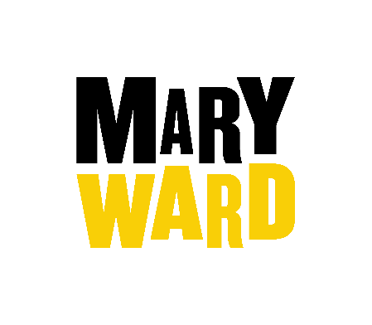


Application Form

Please complete the full application form and return to: recruitment@marywardcentre.ac.uk
(If possible, please return the form in a word document)
Application for:

- PERSONAL DETAILS
Surname: |  |  | Forename(s):
 |  |  | Tel (daytime):
Address: |  |  | Tel (eve):
 |  |  | E-mail:
 |  |  | NI number:
 |  |  | DOB
 |  |  | Do you have the current right to work in the UK: | YES/NO
Postcode:
- EDUCATION AND QUALIFICATIONS
Higher/further education
Institution | Exams
(name/address) | Date | Qualification | Grade

Secondary education
School | Exams
(name/address) | Date | Level | Subject | Grade

Professional training
Any technical, professional or occupational training/courses attended (please start with your most recent training)

Membership of professional institutions/societies
Institution | Admission date | Class of membership/Number

- WORK HISTORY
Current/most recent employer
Company: |  |  | Job title:
Address: |  |  | Date started:
 |  |  | Date left:
 |  |  | Reason for leaving:
Postcode: |  |  | Notice period:
Responsibilities (brief):

Other Employment
Employer
(name/address/tel) | Role & duties | Date started | Date left | Reason for leaving

Voluntary/Community activity/ Public Positions
Please give detail of any relevant voluntary / community activity or public positions held

Employment Gaps
Please give details of any gaps in your employment history record, including unemployment.
From (Month/Year) | To (Month/Year) | Reason(s)

- SUPPORTING STATEMENT
(Which should state how your experience and achievements meet the job description and the selection criteria given in the person specification for the post for which you are applying. Please use a maximum of three additional A4 sheets if necessary. Short-listing of candidates for interview will be made on the evidence given in the supporting statement).

- OTHER INFORMATION
Are you related to any employee or member of the committee at the Mary Ward Settlement? | YES / NO  If yes, please give details:
Where did you see this post advertised?

- Criminal Records Disclosure
Because of the nature of the work for which you are applying, enquiries may be made of the Disclosure and Barring Service to ascertain whether or not your records reveal any criminal convictions. The post is exempt from the provisions of Section 4 (2) of the Rehabilitation of Offenders Act 1974 (Exemptions) Order 1975.

If you are offered a position, you will be required to declare all spent and unspent convictions. The Mary Ward Settlement encourages applicants to disclose any spent or unspent convictions.

Have you ever been convicted, bound over or cautioned in respect of a criminal offence? (Declaration subject to the Rehabilitation of Offenders Act 1974) Do you have any prosecutions pending against you?

Yes / No

If yes, please provide details in a password protected document

- REFERENCES
Please give the name, address, and contact details for two referees – one should be your current or most recent employer. We do not accept personal or character references. Please indicate if we may NOT approach them prior to interview.

First referee |  |  | Second referee
Name: |  |  | Name:
Address: |  |  | Address:
How they know you: |  |  | How they know you:
Tel: |  |  | Tel:
E-mail: |  |  | E-mail:
Contact: | Before/after interview |  | Contact: | Before/after interview

‘This organisation is committed to safeguarding and promoting the welfare of clients and expects all staff and volunteers to share this commitment.’

- DECLARATION
I declare that the information given is true and correct. I give consent to my referees being contacted as indicated. I understand that the information on this form will be processed by the MWS for the purpose of recruitment and personnel administration. I understand that canvassing or giving false information will disqualify my application, or if discovered after appointment, may be grounds for dismissal.

[Please note: if you are unable to sign the form online, please print your name in the signature line]

Signature: Date:

Your signature on this document gives the Mary Ward Centre the right, under the Data Protection Act 1998, to process the information you have given, including data of a sensitive nature, for processes relating to your application for employment, which have been notified to the Offices of the Information Commissioner. Any processing of the data by the Centre will be in accordance with the Centre’s Data Protection Policy and the processing principles set out in the Act. Application forms of unsuccessful candidates will be destroyed after 6 months.

Data Protection Privacy Notice - Job applicants

The Settlement processes personal data relating to job applicants for vacancies as part of its normal operational activities. Personal data is any information that can be identified to a specific, living individual and processing means collecting, holding or using that information. The Settlement’s registered office is 275-285 High Street, Stratford, E15 2TF. All references to the Settlement apply equally to its constituent parts: the Mary Ward Centre, the Mary Ward Legal Centre and the Blackfriars Settlement.
The Settlement’s Data Protection Officer is the clerk, Beverley Campbell. Beverley can be contacted by email – beverley.campbell@marywardcentre.ac.uk.
The reason for collecting this personal data is to fulfil our obligations to you as a candidate. We also have a legal obligation to gather equality data so that we can try to ensure that our recruitment practice is open and fair. This means the legal basis for processing is (a) in order to fulfil our legal obligations, and (b) because it is necessary to fulfil the legitimate purposes of the Settlement. For successful candidates we will keep staff related data for 6 years after the date an individual leaves the employment of the Settlement. This is to enable to offer references that are as full and accurate as possible. For unsuccessful candidates we keep the data for 6 months.
This personal data will only be shared with an organisation that has a legal right to see it. In practice this makes it highly unlikely that the information will be shared with anyone until the individual becomes an employee of the Settlement. At this point they will receive a privacy notice relevant to staff. Equality data is not reported at an individual basis and so no personal data is ever shared. We will not share your personal data with anyone for the purpose of sales or marketing.
Under UK legislation there are a number of principles that apply to all types of personal data. The individual, to whom the data refers, also has a number of rights concerning their data. More information about both of these things can be found on our web-site at www.marywardcentre.ac.uk/GDPR. If you are not satisfied that your personal data is being processed properly, and the Settlement has been unable to deal with your complaint satisfactorily, then you have the right to raise your concern with the Information Commissioner’s Office (ICO). More information about how you can do this is available at the ICO’s web-site www.ico.org.uk.

