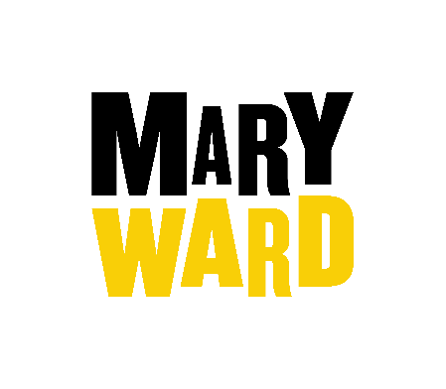
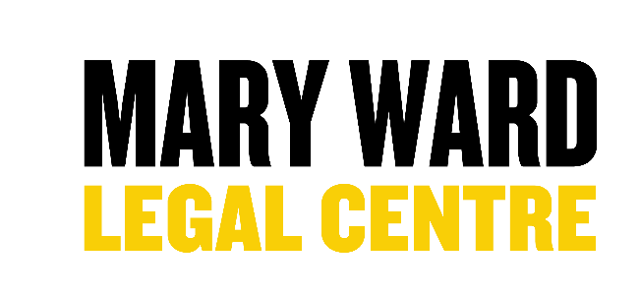

The Mary Ward Centre is committed to equality of opportunity in employment and to the selection of the best person for the job. The information you are providing on this page is anonymous and is used for monitoring purposes only. It is not used in the selection process. This form should be returned with your application form but will be removed from your application prior to short-listing.

Post Applied For:
First Name
Surname

Gender

Male Female Intersex non-Binary Prefer not to say

If you prefer to use your own gender identity, please write in:

Is the gender you identify with the same as your gender registered at birth?

Yes No Prefer not to say

Age

Under 18 18-25 26-35

36-45 46-55 56-65

Over 65 Prefer not to say

Ethnic Origin

Asian/ Asian British – Bangladeshi Mixed – White and Asian

Asian/ Asian British – Indian Mixed – White and Black African

Asian/ Asian British – Pakistani Mixed – White and Black Caribbean

Asian/ Asian British – Other Mixed Other

Black/ Black British – African Prefer not to say

Black/ Black British – Caribbean White - British

Black/ Black British – Other White - Irish

Chinese White - Other

Other (please specify)

Sexual Orientation

Heterosexual Gay Lesbian Bisexual Asexual

Pansexual Undecided Prefer not to say Other (please specify)

Religion

Buddhist Christian (including all denominations) Hindu

Jewish Muslim No religion

Prefer not to say Sikh

Other (please specify)

Disabilities and existing health issues

Do you consider yourself to have a disability or an existing health issue which has an adverse effect on your ability to carry out normal day to day activities?

Yes No Prefer not to say

If Yes, please describe the nature of your disability or existing health issue

Please let us know in the space below if you have any reasonable adjustments to be made at the interview, or if there is anything you would like to make us aware of.

Declaration

I understand by signing this form, the information given on this form will be processed by and used for registration and equality monitoring purposes under the Data Protection Act 1998. By signing below you confirm you have read, understood and agreed with his declaration.

Signed |  | Date

